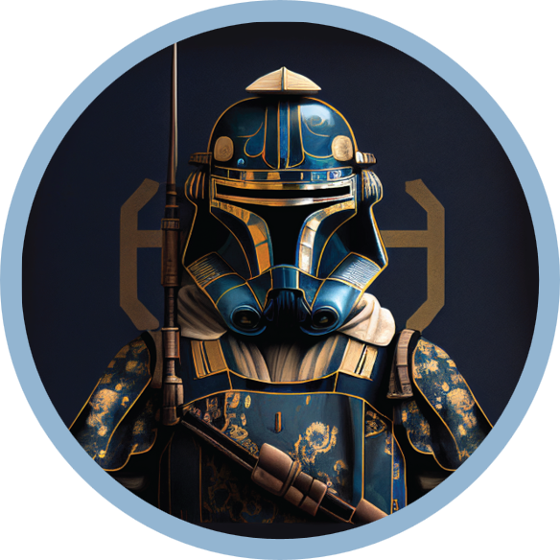 |  | Ewuzie Chinaecherem Peter  [HigherHigh I Petrex]  Web3 Management  Lagos, Nigeria  About Ewuzie Peter,  I am a Blockchain and Web3 design enthusiast with solid knowledge of different DAOs operational guilds. I am willing to provide efficient service for the expansion of Web3 projects. I am quite familiar with the process of project expansion and coordination in communities to achieve the required goals.  WORK EXPERIENCE  COMMUNITY MODERATOR  - Community Moderator at WeUp Server.  - Community Ranger at DIA telegram channel  - Once a Beta Mod at Altverse DAO/  - Product tester for CERE protocol  COMMUNITY DESIGNER  - Designer at Apollo DAO  - Social media designer for Ricochet exchange.  - Infographics designer at Sarcophagus DAO and DUA DAO.  SKILLSETS  Graphics designer ▪︎ Planning and Coordination •Active Listening skills •Discord Server Organization •Discord Bot Management •Administration and Management •Able to Make Quick Decisions •Content Creator (Articles About Crypto Ecosystem) •Reading Comprehension and Responding •Patient •Quick Learner ▪︎ Fun person ▪ Able to keep the community active  LANGUAGES  English  SPECIALIZATION  Graphics Designs, Web3, UI/UX, Community Manager, Activity planner, Content Writer, DAO Collaborations, NFT

HIGHERHIGH PETREX
Community mod
graphics designer

CONTACT
PHONE:
+2349082602726
DISCORD:
HIGHERHIGH|PETREX👻#9227

TWITTER: TIMEZONE
@PetrexTots GMT+1

EMAIL:
Petrexpee@gmail.com

