

Contact

Phone

+639482440973

Email

[janmarcdalapu1@gmail.com](mailto:janmarcdalapu1@gmail.com)

Address

P-6 Balbarino Subd, ButuanCity, Agusan del Norte

Education

2013 - 2017

**Bachelor of Science in Information Systems**

**Caraga State University – Main Campus**

Expertise

Hardware & Software Maintenance Inventory Management Data Analysis

Problem-Solving

Communication and Interpersonal Skills Technical Support and Troubleshooting Organizational Skills

Adaptability and Flexibility

Proficient in MS Office

Photo & Video Editing (Photoshop & Canva)

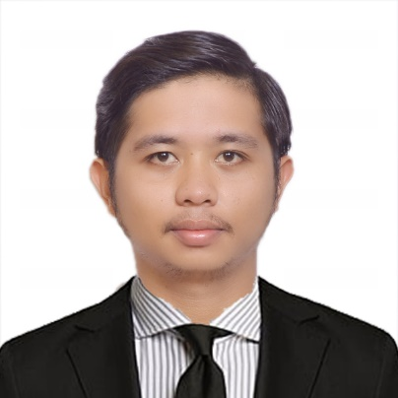

Jan Marc S. Dalapu

Social Media Manager

Motivated and detail-oriented professional seeking a challenging role as a Social media Manager. Leveraging strong work ethic, exceptional organizational skills, and a passion for delivering outstanding customer experiences. Eager to apply transferable skills gained from diverse work experiences to drive operational excellence and contribute to the success of a dynamic organization.

Experience

## February 2023 – December 2023



Super Deal Motors – Car Dealership | N STATE RD 7, Hollywood FL

# Freelance Graphic Artist / Social Media Manager

Manage and maintain quality assurance of Social media post in Instagram and Customer Service.

Design banners, posters, videos and create graphic design to be posted on Instagram. (Photoshop, Canva & Postermywall)

Create marketing strategy to boost social media engagement and sales thru online.

## April 2022 - December 2022

Grand Palace Hotel l Montalban St., Butuan City

# IT Personnel

Managed and maintain server, computer systems, networks, and software applications. Assist in the troubleshooting of technical issues, providing prompt resolutions to minimize downtime (both employees and hotel clients & conventions)

Collaborate with colleagues to enhance data security measures and ensure the integrity and confidentiality of information.

CCTV Maintenance & Monitoring, Lay out & Graphic Artist (Photoshop, Canva & Postermywall)

## October 2021 - April 2022

TESDA Agusan Del Sur - Provincial Office l GDOP, Patin-ay, Agusan del Sur

# IT Support Staff

Provided technical support and troubleshooting for computer systems, software, and network-related issues.Assisted in the maintenance and management of IT infrastructure, including hardware installations and software updates.

Supported the implementation of IT projects and contributed to the improvement of IT processes and procedures.

CCTV Maintenance & Monitoring, Lay out & Graphic Artist (Photoshop, Canva & Postermywall)

Reference

**Jesterlyn Q. Timosan**

Chairperson IT Department, Caraga State University – Main Campus

**Phone:** +639468816873

**Mr. Edgar Cuenca**

SHS Teacher

SHS Carmen, Agusan del norte

Phone: 09368186143

**Mr. Levi Balbarino**

Principal

Pagatpatan National Highschool

Phone: 09297951946

## August 2018 - November 2018



Amaris Merav Corporation l Butuan City

# Inventory Analyst

Conducted regular inventory counts, monitored stock levels, and maintained accurate records of merchandise.

Analyzed sales data and inventory reports to identify trends and optimize stock ordering and replenishment processes.

Collaborated with cross-functional teams to ensure smooth inventory management and efficient supply chain operations.

## April 2018 - May 2018

Philippine Statistics Authority – Provincial Office l Butuan City

# Map Data Collector

Conducted field surveys to collect geospatial data for various mapping projects, adhering to established data collection protocols.

Utilized GPS devices and other surveying equipment to capture accurate coordinates and attribute data.

Ensured data quality and integrity by conducting thorough data checks and validation

during the collection process.

Collaborated with team members to resolve any data collection issues and ensure project milestones were met.

**August 2017 – November 2017** Codev Philippines l Cebu City

**Events Verification Specialist**

Maintained accurate attendee records and databases, ensuring data integrity and

privacy.

Audit every upcoming and current events in every state in the USA. Delete all redundant posted events and maintain quality assurance of the website.