**Hard and Soft Sounds**

**Colour the boxes with the hard sound of the letter ‘g’.**

|  |  |  |
| --- | --- | --- |
| age | go | gum |
| magic | giant | stage |
| grab | energy | gold |

**Colour the boxes with the soft sound of the letter ‘c’.**

|  |  |  |
| --- | --- | --- |
| cab | rice | cow |
| face | cent | car |
| city | cold | pencil |

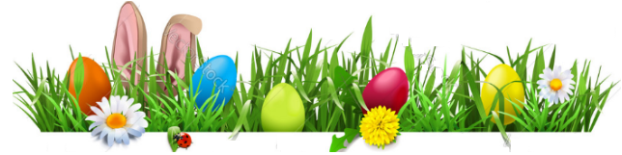

**Articles**

**Fill in the blanks using ‘a’ or ‘an’.**

* She read _____comic book.
* Iqra went on _____ trip.
* He likes to read _____short story.
* Liaq ate _____orange.
* My mom is making _____cake for me.
* The dog caught ­_____stick.
* I saw _____elephant at the zoo.
* She gave me _____cookie.
* ­_____ oval is shaped like _____egg.

**Multi-syllable Words**

**Read the given text and find five multi syllable words. Note them down.**

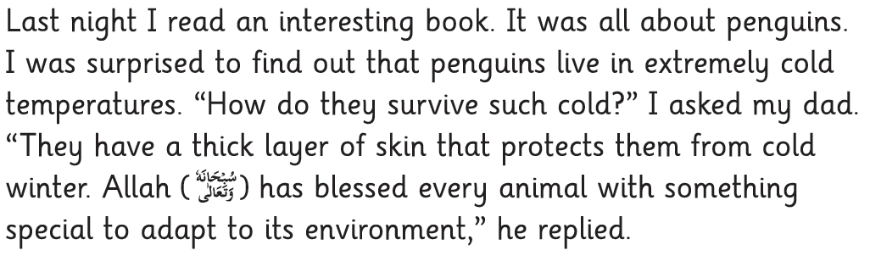

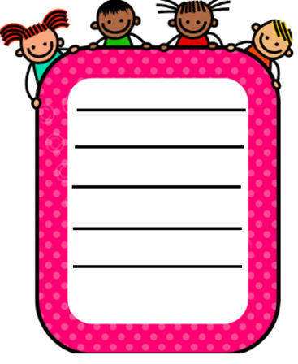

**Silent Letters**

**Read the given words and circle the silent letter in each.**

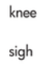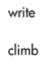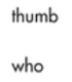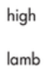

**Adjectives**

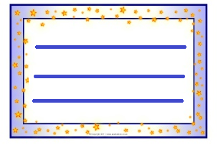**Write adjectives of the given types.**

**Adjective of Quality**



**Adjective of Quantity**



**Adjective of Size**



**Adjective of Colour**

**Question Words**

**Write a question using each question word.**

**How:___________________________________________________________________________________________**

**Who:___________________________________________________________________________________________**

**Whose:___________________________________________________________________________________________**

**Where:___________________________________________________________________________________________**

**Which:___________________________________________________________________________________________**

**Anagrams**

**Make anagrams of the given words.**

1. **shore ___________**
2. **low ___________**
3. **tan ___________**
4. **tab ___________**
5. **loin ___________**
6. **nails ___________**
7. **reed ___________**
8. **pea ___________**
9. **stop ___________**
10. **race ___________**

**Long and short vowels**

**Write two words with each given vowel sound.**

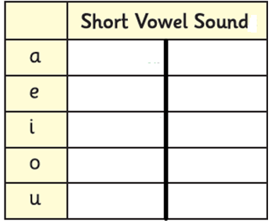

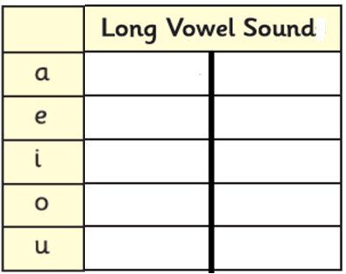

**Diphthongs**

**Write two words with each given diphthong.**

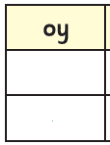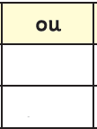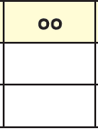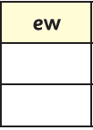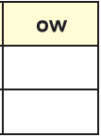

**Joining Words**

**Fill in the blanks using the given joining words.**



1. Iqra _____ I are best friends.
2. Do you want to go with me _____ stay home?
3. She couldn’t come to school _____ she was sick.
4. I want to go on her birthday party _____ I am busy.
5. Would you like to take tea _____ juice?
6. I want to eat an orange _____ an apple.
7. He performed well in the exams ­_____ he worked hard.
8. I went to the market _____ couldn’t get my favourite shoes.

**Alphabetical Order**

**Arrange the given words in alphabetical order.**

1. **runner, race, rush, ran**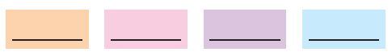
2. **paint, peak, phone, pink**



1. **blow, cloud, glow, flow**



1. **stand, sleep, soak, snow**



1. **east, eagle, end, easy**



**Position Words**

**Write two sentences using each given position word.**

**on**

1. **________________________________________________**

**________________________________________________**

1. **________________________________________________**

**________________________________________________**

**beside**

1. **________________________________________________**

**________________________________________________**

1. **________________________________________________**

**________________________________________________**

**above**

1. **________________________________________________**

**________________________________________________**

1. **________________________________________________**

**________________________________________________**

**Commands**

**Read the given sentences. Underline the command sentences.**

1. Tidy up your room.
2. Get some fruits for me.
3. This is an informative book.
4. He is sleeping.
5. I love ice cream.
6. Feed the cat.
7. Close the door.
8. Give me this bag.
9. What time is it?
10. Write on the piece of paper.

**Synonyms**

**Match the synonyms.**

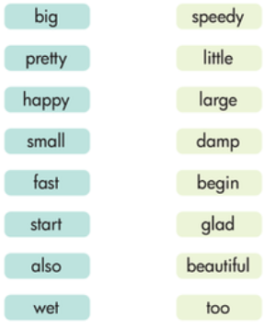



**Consonant Clusters**

**Make two words with each given consonant cluster. One has been done for you.**

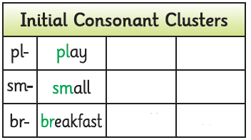

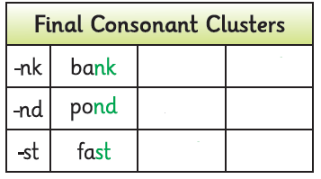

**Countable and Uncountable Nouns**

**Write the given nouns in the correct boxes.**

|  |  |  |
| --- | --- | --- |
| **information** | **towel** | **water** |
| **shop** | **rice** | **country** |
| **furniture** | **student** | **song** |
| **advice** | **picture** | **research** |

|  |  |
| --- | --- |
| **Countable**  **_________**  **_________**  **_________**  **_________**  **_________**  **_________**  **_________** | **Uncountable**  **_________**  **_________**  **_________**  **_________**  **_________**  **_________**  **_________** |

**Possessive Words**

**Write a sentence using each given possessive words.**

**my:___________________________________________________________________________________________**

**his:___________________________________________________________________________________________**

**her:___________________________________________________________________________________________**

**its:___________________________________________________________________________________________**

**your:___________________________________________________________________________________________**

**their:___________________________________________________________________________________________**

**Be, do and Have as Main Verbs**

**Write sentences using the given ‘be’, ‘do’ and ‘have forms as main verbs**

**am:______________________________________________________________________________________________________**

**have:______________________________________________________________________________________________________**

**had:______________________________________________________________________________________________________**

**did:______________________________________________________________________________________________________**

**was:______________________________________________________________________________________________________**

**is:______________________________________________________________________________________________________**



**Antonyms**

**Write the antonyms of the given words.**

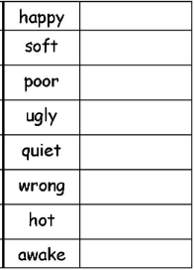

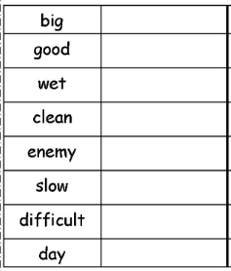

**Singular /Plural**

**Write the plural nouns of the given singular nouns.**

|  |  |
| --- | --- |
| **room** | **__________** |

|  |  |
| --- | --- |
| **key** | **__________** |

|  |  |
| --- | --- |
| **candy** | **__________** |

|  |  |
| --- | --- |
| **tomato** | **__________** |

|  |  |
| --- | --- |
| **cherry** | **__________** |

|  |  |
| --- | --- |
| **kiwi** | **__________** |

|  |  |
| --- | --- |
| **bunny** | **__________** |

|  |  |
| --- | --- |
| **peach** | **__________** |

**Punctuation Rules**

**Punctuate and rewrite the following sentences.**

1. **i love my parents**

**__________________________________________________**

1. **my grandparents also live with us**

**__________________________________________________**

1. **we should help and respect each other**

**__________________________________________________**

1. **we are a happy family**

**__________________________________________________**

1. **i love my country**

**__________________________________________________**

**Words Meanings**

**Write meanings of the given words.**

|  |  |
| --- | --- |
| **Word** | **Meaning** |
| useful |  |
| moment |  |
| stranger |  |
| worried |  |
| personality |  |
| minority |  |

|  |  |
| --- | --- |
| **Word** | **Meaning** |
| various |  |
| ahead |  |
| disappoint |  |
| realise |  |
| might |  |
| rule |  |

**Comprehension**

**Read the given passage and answer the following questions.**

**Favourite Dinner**

Ayesha loves it when her grandfather comes to visit once a month from Karachi. Her grandfather makes her favourite dinner and always tells her amazing stories. Ayesha wishes that her grandfather would visit more often.

Ayesha loves the barbeque chicken that her grandfather makes for her. She always asks her mother to make it.

“I can make it for you but I don’t think it will be as good as your grandfather makes,” says her mother.

As her mother prepares the chicken, Ayesha watches her make the tasty sauce. When they sit down to eat, Ayesha smiles as her mother was right about her grandfather making the chicken much better than her mother. Ayesha tells the story about her mother trying to make the barbeque chicken when her grandfather comes for a visit. Her grandfather enjoys the story and says, “That story is very funny.” Her grandfather then decides to teach Ayesha’s mother how to make his special chicken dinner.

Once a week, Ayesha and her mother make the barbeque chicken but it still does not taste as good as her grandfather makes it. Ayesha really loves and respects her grandfather.

1. **When does Ayesha’s grandfather come to visit?**

**__________________________________________________________________________________________________________________________________________________________________**

1. **Where does Ayesha’s grandfather live?**

**__________________________________________________________________________________________________________________________________________________________________**

1. **What favourite dinner does her grandfather make?**

**_____________________________________________________**

**_____________________________________________________**

**_____________________________________________________**

1. **How does Ayesha’s mother learn how to make the barbeque chicken?**

**__________________________________________________________________________________________________________________________________________________________________**

**Read the given poem and answer the following questions.**

**Ten Cookies**

I have ten yummy cookies all in a line –

I gave one to my little sister, now there are nine.

I have nine cookies that smell really great –

My older brother took one, now there are eight.

I have eight cookies fresh from the oven –

The cat grabbed one, now there are seven.

I have seven cookies that look like bricks –

Mom dropped one on the ground, now there are six.

I have six cookies and went for a drive –

Someone ate one, now there are five.

I have five cookies but I want more –

Dad ate one, now there are four.

I have four cookies and I want tea –

My cousin took one, now there are three.

I have three cookies and tied my shoe –

A crow grabbed one, now there are two.

I have two cookies and sat in the Sun –

Grandfather took one, now there was one.

I have one cookie but I have to run –

Grandma ate the last one and now there was none.

1. **How many cookies were left after his grandfather ate one?**

**__________________________________________________________________________________________________________________________________________________________________**

1. **Who ate the cookie when he tied his shoe?**

**__________________________________________________________________________________________________________________________________________________________________**

1. **What did mom do with the cookie?**

**__________________________________________________________________________________________________________________________________________________________________**

1. **How many cookies did his older brother eat?**

**__________________________________________________________________________________________________________________________________________________________________**

**Read the given passage and answer the following questions.**

**Amazing Fish**

“Mother check out this amazing fish! It looks like salmon,” said Qasim.

“Where did you find such an amazing fish, Qasim?” asked his mother.

“My friend Hassan and I found it in the brook when we went to get some water. We used Hassan’s net to catch the fish and put it in this big bowl.”

“What are you going to do with such an amazing fish?” Qasim’s mother asked.

“I want to keep it and take care of it,” said Qasim.

“I don’t think your fish will survive in that bowl. I think it is better that you let it go in the brook,” said his mother.

Qasim was said and upset. “I really want to keep this amazing fish! Can’t I just put it in a bigger bowl?”

“That is not possible, Qasim,” said his mother. “Salmon can’t live in warm water and if you want it to survive, you have to put it back in the brook.”

1. **How did Qasim catch the fish?**

**__________________________________________________________________________________________________________________________________________________________________**

1. **Who is Hassan?**

**__________________________________________________________________________________________________________________________________________________________________**

1. **What type of fish did Qasim find?**

**__________________________________________________________________________________________________________________________________________________________________**

1. **Why does Qasim’s mother tell him to return the fish to the**

**brook?**

**__________________________________________________________________________________________________________________________________________________________________**

**Creative Writing**

**Write a rhyme poem of your own.**

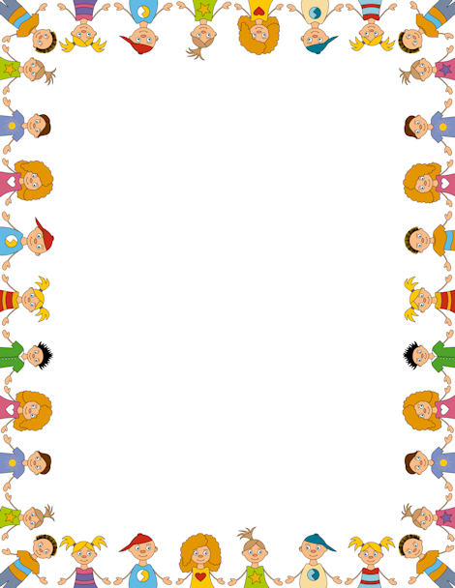

**Topic: _______________**

____________________________________________________________________________________________________________________________________________________________________________________________________________________________________________________________________________________________________________________________________________________________________________________________________________

**Write a paragraph on the topic ‘A visit to the Zoo’.**

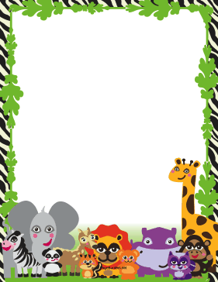

**A Vsit to the Zoo**

______________________________________________________________________________________________________________________________________________________________________________________________________________________________________________________________________________________________________________________________________________________________________________________________________________________________________________________________________________________________________________________________________________________________________________________________________________________________________________________________________________________________________________________________________________________________________________________________________________________________________________________________________________________________________________________________________________________________________________________________________________________________________________________________________________________________________________________________________________________________________________________________________________________________________

**Write a paragraph about your favourite personality.**



**My Favourite Personality**

____________________________________________________________________________________________________________________________________________________________________________________________________________________________________________________________________________________________________________________________________________________________________________________________________________________________________________________________________________________________________________________________________________________________________________________________________________________________________________________________________________________________________________________________________________________________________________________________________________________________________________________________________________________________________________________________________________________________________________________________________________________________________________________________________________________________

**Fill in the following story web to write a story of your own.**

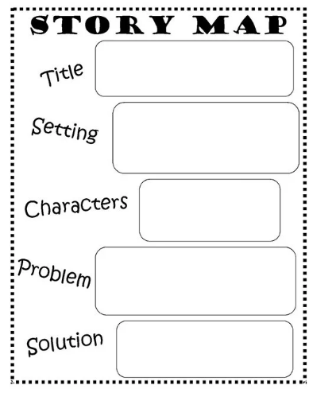

**Now write the story.** 