Mohamed .S. Ismael

**Head of the statistics & planning department of Tishreen university-Freelancer translator**

**Nationality:Syrian**

**Age:32**

**Mobile 00963951653227**

**Military Service:Exempted**

[fasskiez@yahoo.com](mailto:raed.alkhedr@souqelmal.com)

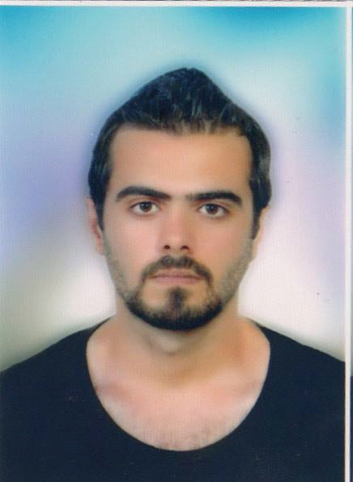

**Practical Skills:**

* Preparingand setting the budgets.
* Executing budgets.
* Setting & executing monthly, quarterly reports.
* Setting charts and indicators.
* Setting tables and statistics based on statistical standards.
* Data analysis.
* Ability to collect ,process and analyze data to compile information and to set reports.
* Strong interpersonal communication skills: both verbal and written.
* Specialized in all the statistical programs related to statistical analysis.
* Acting the university plans, managing all university budgets, arranging university funds and liquidity sources, after making comparison researches and choosing the best financial budgetbased on accurate scientific standards.
* Performing feasibility studies of all university's projects based on scientific and organized methods.
* Executing daily administrative works.
* Data mining of university faculties (students, staff, teachers……,etc).
* Documenting and archiving papers based on years, type and date.

**Experience:**

* **June 2004 to 2006 – Waiter at la Cote de Azor Syria-lattakia .**
* Delivering customerrequirements.
* Washing dishes.
* Cleaning&tiding&washing.
* **June 2006 to August2009 – Clerk at the department of agricultural affairs.**
* Supplying army units& establishments barracks with money, studies ,plans ,food…..etc.
* Managing cropsdevelopment.
* Observing work development.
* Purchasingitems for workers and crops.
* Managing inventory.
* Establishing communications between workers& engineers in order to achieve goals.
* Setting monthly-quarterly-annually reports based on scientific standards.
* **Septemper2011 -August2012 Accountant at Mango- Mango**
* Pricing items.
* Establishing communication with the head office in order to file reports about the changes in prices and amounts.
* Handling the store inventory.
* Executing all financial orders.
* Paying wages.
* **August 2009-March 2011 military affairs institution department of housing&construction - governmental institution.**
* Painting workshop.
* Infrastructures.
* **July2010 - December2011 Galaxy Group.**
* Contacting customers, discussing their financial budgets&their best investment strategies &account types.
* Handling customer documents.
* Following up daily reports.
* Instant translation of instant reports.
* Handling weekly & monthly indoor meetings with the administration staff.
* **November2012 - June2018 SCIT- translator-Editor-Copywriter.**
* Translating company documents and contracts.
* Software researches.
* Students researches.
* Delivering reports on time.
* **August 2016 – May 2022 Casino Hex- translator.**

• Translating.

• Editing.

• Proofreading.

• Copywriting.

• Content writing.

* **November 2017 – December 2021 Unbabel- translator-Editor.**

• Translating.

• Editing.

• Proofreading.

* **August 2016 – May 2022 nZeros Limited- translator.**

• Translating.

• Editing.

• Proofreading.

• Copywriting.

• Content writing.

* **March 2018 – March 2022 Ligy LTD- translator.**

• Translating.

• Editing.

• Proofreading.

* **November 2018 – May 2022 Midlocalize- translator.**

• Translating.

• Editing.

• Proofreading.

• Subtitling.

• Transcribing.

**Education:**

-Faculty of Economics,Tishreen university**,** statistics & programming department, with focus on new methods of statistics & total quality management(QTM),quality control(QC),graduated 2009-2010.

-Faculty of Economics, Tishreen university, diploma in statistics&programming,(quality control). ,graduated 2010-2011.

-Faculty of Economics, Tishreen university, studying master in statistics & programming(quality control).

-Faculty of Arts and Humanities,Tishreen university, translation department, with focus on simultaneous translation, written&oral translation ,graduated 2009-2010.

-NLP certificate 2012

**Languages:**

Arabic: mother tongue.  
English: excellent reading and writing conversation.

**Skills:**

* Excellent knowledge of PC windows environment and office applications, internet search, and researches.
* Excellent knowledge of various international accounting and statistical software.
* Highest commitment to quality customer service with the ability to work with a team and unsupervised.
* Excellent communication skills, both written and verbal.
* Ability to multi-task and work in a fast paced environment.
* Strong computer skills; Ability to learn and work with new programs.
* Bilingual language skills A plus.
* Pr.manager.
* Teaching.
* Academic searching.
* Self-learning.
* Teamwork
* Workshop development.
* Training.
* Working at home translation students papers,reports,master students documents
* Specialized in economical translation.

All supporting documents and certificates will be furnished upon request.