Curriculum Vitae
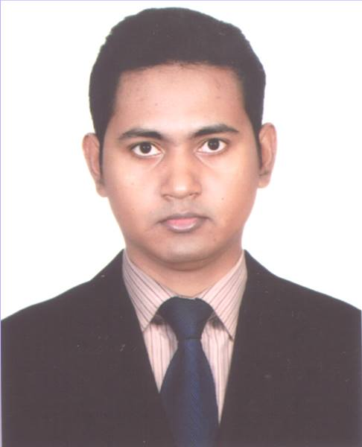

Zamshed Arafat

415 North kazipara,

Mirpur-10,Dhaka-1216
Mobile: 01716321281 ,
E-mail: jamson_arafat@yahoo.com

Personal Profile

I am energetic and ambitious person who has developed a mature and responsible approach to any task that I undertake or situation I am presented with. As a Masters Degree holder in management and with experience in Sales and Data process in reputed company I am excellent in working with others to achieve a certain objective on time with excellence.

Achievements

- Received award.
- Been complimented by supervisor.
- Contributed to good customer service.
- Worked on special projects.
Education

2015 Masters (M.B.S) Govt Bangla College.
Grade achieved: Second Division

2010 Bachelor (B.B.S) Tejgao College.
Grade achieved: Second Division

2006 Higher Secondary (H.S.C) Sonapur Degree College.
Grade achieved: B

2004 Secondary (S.S.C) Brother Andre High School.
Grade Achived : A-
Work Experience

Jan2020 – Sept 2022 Data Analyst Kazi It Center

Main duties performed: Collect and process data for American clients, Communicatin .

Jan 2018 – Dec 2019 Data Entry Operator Gabino Tech Solution

Main duties performed: Perform Data Entry, Hand writing to softwar data entry.
Personal Information

Name : Zamshed Arafat.
Date of birth : 1st January,1988.
Gender : Male.
Marital Status : Unmarried.
Nationality : Bangladeshi.
Language Known : Bangla (Native),
: English.
Skills

Interpersonal:

- Good Command over English. (IELTS-6)
- English Typing Speed 30+
- Can Communicate with people of English spoken country.
- Ability to work under pressure.
- Time Management.

Computer Skill

Good Typing in Both English and Bangla, Proficient with Microsoft word and excel, Email, Face book, Twitter, Skype, Cell phone technology,

Hobbies and Interests

- Travelling, Fishing.
- Sports (walking, exercise).
- Reading, Writing.
- Music listening.

Sincerely

