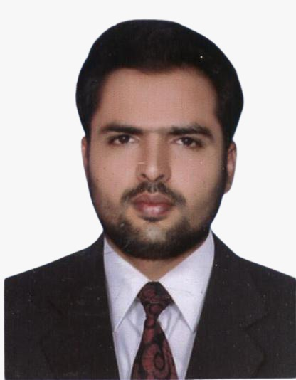

Bilawal Ali Qaiser

*Curriculum Vitae*

*P-31, Street # 2 Ali Villas town National Silk Mill Road*

*Faisalabad, Pakistan (+92) 344 6009934*

[*bilawal.jutt@gmail.com*](mailto:bilawal.jutt@gmail.com) *Date of Birth: 02.02.1989*

*Place of Birth: Faisalabad (Pakistan)*

# Education

03/2011 – 03/2013 **Government College University Faisalabad (Pakistan)**

Masters of Commerce (M.Com) Finance Specialization

Graduation Division: 1st

09/2007 – 02/2010 **University of the Punjab (Pakistan)**

Bachelor of Commerce majors in Accounting and Finance

Graduation division: 1st

09/2005 – 08/2007 **Board of Intermediate & Secondary Education, Faisalabad (Pakistan)**

Inter with Computer Science

08/2002 – 05/2004 **Board of Intermediate & Secondary Education, Faisalabad (Pakistan)**

Matric with Computer Science

# Work Experience

11/2017 – Present **Learning Alliance/Lahore Preschool (Preschool to A Level)**

**Faisalabad Campus (Faisalabad Pakistan)**

Branch Accountant

Tasks & Projects:

* Generating and posting students fee vouchers
* Fee reconcile with bank on daily & monthly basis
* CPVs, CRVS, BRVs & JVs posting
* Management of Credit Cycles

* Payroll management
* Human Resource Management
* Month end Financial Reports
* Bookkeeping to keep all income and expenses record

09/2014-10/2017 **Head Office Butt Sweets & Bakers Lahore (Pakistan)**

Accounts Officer

Tasks & Projects:

* Check entries of sales of 22 outlets & 4 restaurants
* Check entries of expenses of all outlets and restaurants
* Daily type petty cash expenses record of Head office
* Making salaries of more than 2 thousand employees
* Maintain debtors and creditors ledger
* Monthly cost of production reports
* Monthly Financial reports

04/2013-07/2014 **Weldone International (Pesticides firm) Lahore (Pakistan)**

Accounts Officer

Tasks & Projects:

* Daily sales invoicing
* Parties Ledgers
* Factory Head Office Expenses
* Monthly Budgeting

# IT Skills

09/2010 – 02/2011 **Diplomas in Office Management Faisalabad (Pakistan)**

* Windows XP
* Internet, web searching & Email
* Ms Word, Excel, Access & PowerPoint
* Typing

# Language Skills

Urdu National Language

Punjabi Mother Tongue

Hindi Fluent Speaker

English Proficient speaker

# Hobbies

* + Watching and playing sports
  + Reading
  + Travelling