Joao Luiz Flores da Silva
- Email: joaoluizfloresdasilva@gmail.com Mobile: +5551992323534

Academic Background:

Uninter January, 2019-today
Porto Alegre, RS
Management of Defense and Cybersecurity

Experience:

Turtle Finance San Jose, CA
Community Manager April 2021-June 2021
- Answering common questions about the project.
- Promoting the group through Discord, Reddit, Facebook, Twitter, etc.
- Saying ‘’Welcome’’ for each new person that has joined the Telegram group.
- Inviting new people through my social media accounts.
- Reporting offensive comments for any user in the group.
- Sharing for each new user all the instructions and the ‘’white paper’’ of the project, and helping all beginners solve difficult situations.

Netcoins Montreal, Quebec
Writer July 2021-today
- Writing good Quora answers
- Writing good Reddit questions/answers
- Promoting the Exchange through Reddit, and Quora
- Creating new tabs in Google Sheets for each question/answer.
- Sharing good websites about cryptocurrencies(CoinDesk, and Netcoins ‘’blog section’’).
- Using Grammarly Premium to revise each new post.

Skills

- Virtual Assistant
- English proficiency
- Advanced cryptocurrency knowledge
- Spanish (fluency level in reading, speaking, and writing)
- Portuguese (fluency level in reading, speaking, and writing)
- English (fluency level in reading, speaking, and writing)
- Microsoft Office(PowerPoint, Excel, Word 2010)
- Empathy
- Social Media Marketing
- Logical reasoning
- Patience
- Community Management
- Discord
- Marketing
- Good Communication
- Moderate community
- Telegram
- Customer Care

Certificates:
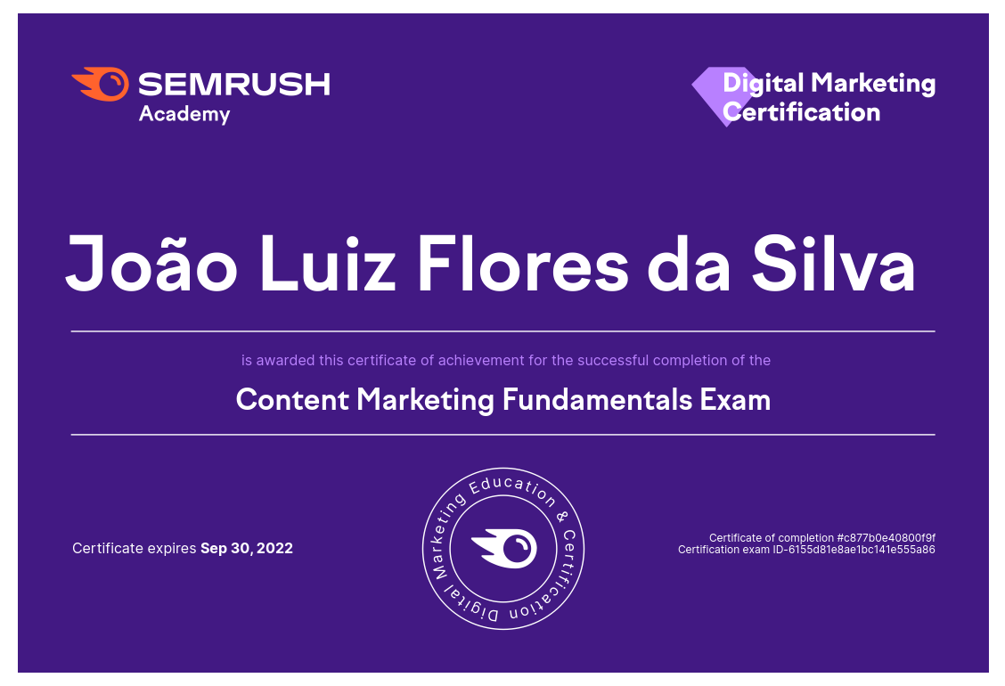

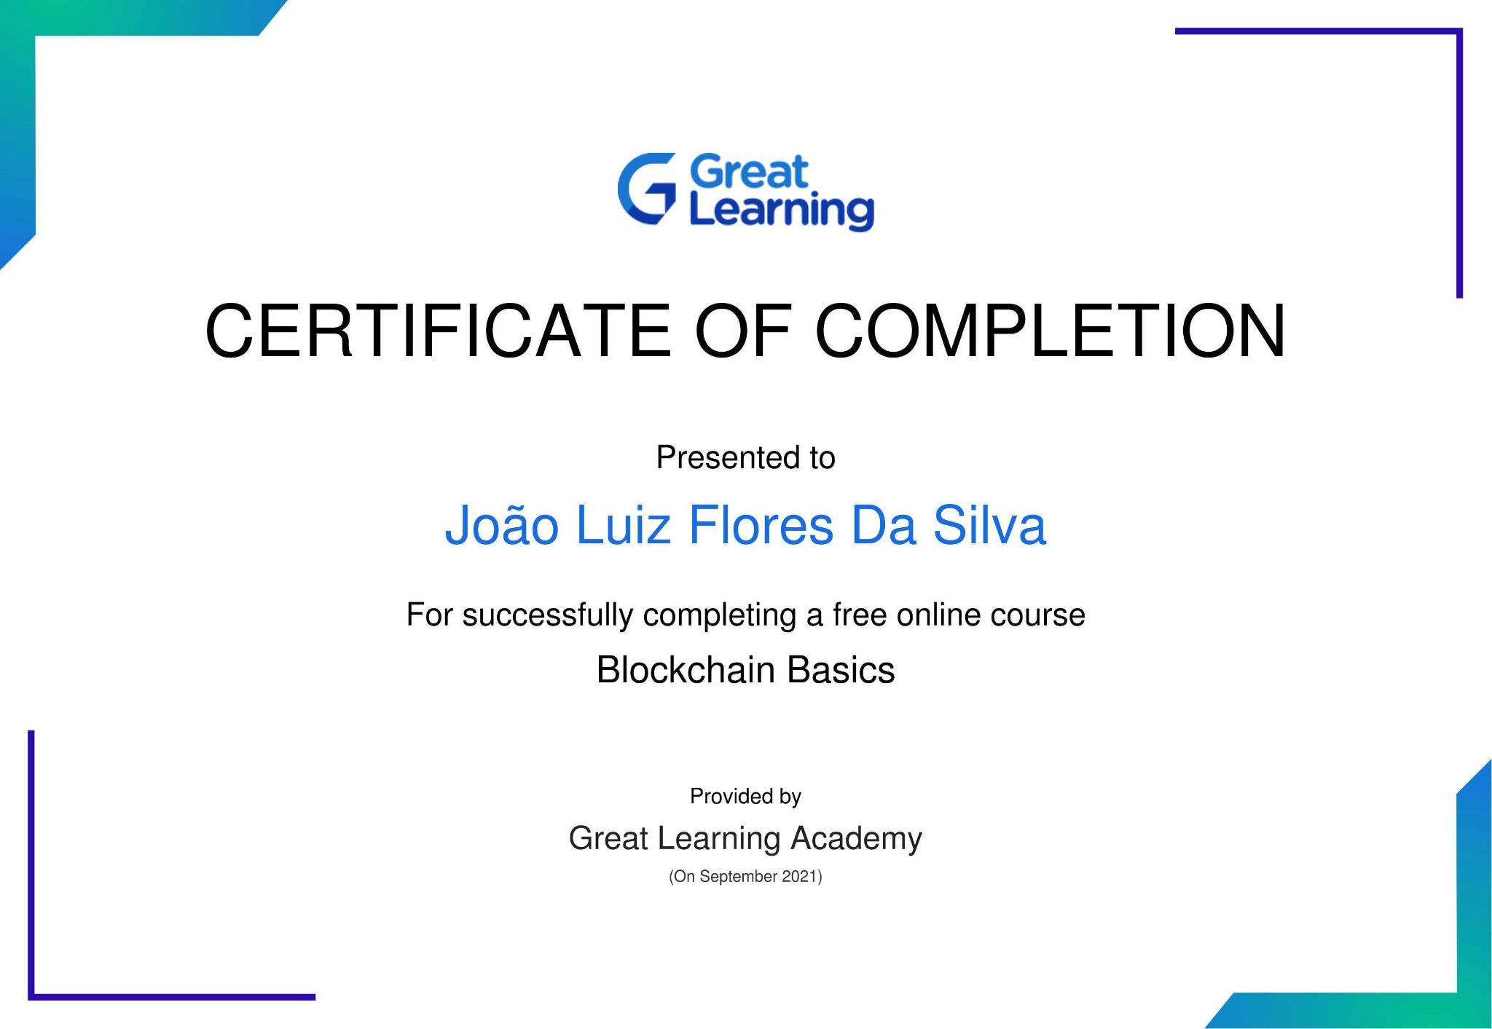

Contact me:

Discord: Jlz2022#5920

Email: joaoluizfloresdasilva@gmail.com

Telegram: @Jlz2023

