OLUWASEUN OYEBODE
39, Faith avenue street, Idi-orogbo, Ori-okuta, Agric, Ikorodu,Lagos
09098775966, 08061781484
Oyebodeseun92@gmail.com

Professional summary

A passionate Physics student ,Forex analyst and trader, full time google ads manager with trend analysis as a point of focus in ensuring that companies and organizations get the most out of digital infrastructures set in place by the evolution of the internet . Looking to leverage my curiosity and technical mindset to solve analytical problems in addition providing the best value possible to organizations using my digital skills.

Education

FEDERAL UNIVERSITY OF TECHNOLOGY AKURE
B.sc Physics [ 2019– date] – 200l
- Majoring in core courses like Python, Quantum Physics and Mathematics.
- A member of FUTA Tecno Ambassadors.

TRUEVINE SECONDARY SCHOOL;2013-2019
- Head boy of the school.
- SSCE certificate with 8 Credits.

EXOUSIA PRIMARY SCHOOL ; 2008- 2013

FIRST FRUIT PRIMARY SCHOOL ; 2004-2008

Further Education
- Mobile App Development: Modeski Business Hub. Completed the two weeks intensive training online.
- Introduction to Photography: Shaw Academy. Completed the course online.
- Forex Training : Completed a two month physical training with a professional FOREX trader.
- Google Ads: Completed a three month physical training with a professional Ads manager from Norland Pharmaceuticals company.

Work experience

NORLAND PHARMACEUTICALS COMPANY
October 2021- Date
Remote
GOOGLE ADS MANAGER
- Create and develop search ads that run for approximately a month.
- Provide analysis of ad performance overtime.
- Relate with potential customers interested in a purchase .
- Modify ads to expand audience reach.

GRAPHICS DESIGN
December 2021 - Date

Skills

Technical Skills:
- Market Trend Analysis
- Trading Strategy
- SEO specialist
- Content Writing

Soft-Skills:
- Leadership
- Team-work
- Patience

Hobbies/Personal interests
I am quite passionate about learning and building capacity especially in the following areas:
- Market Analysis
- Learning
- Research

ADDITIONAL INFORMATION
Google Ads Stats

FIRST AD

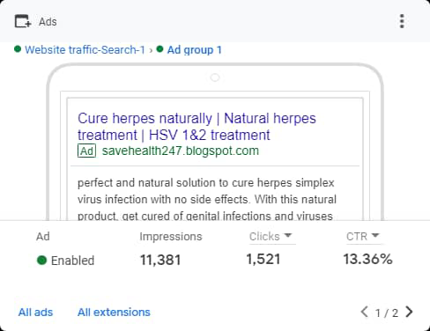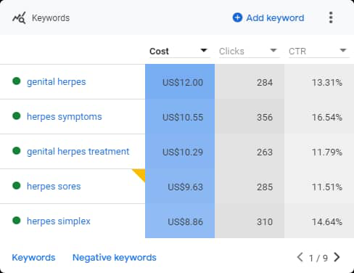it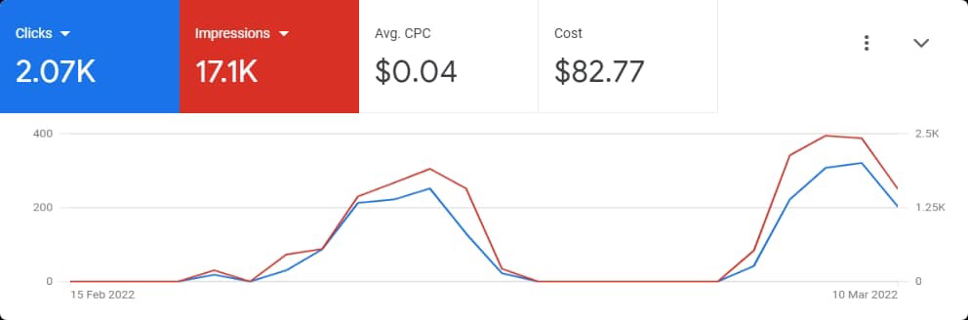
SECOND AD
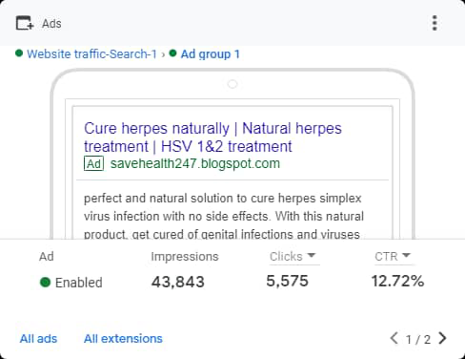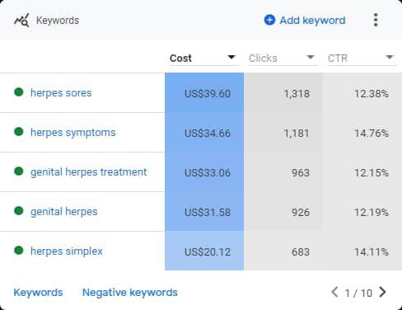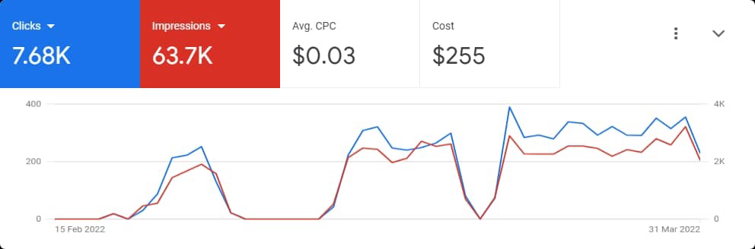
THIRD AD
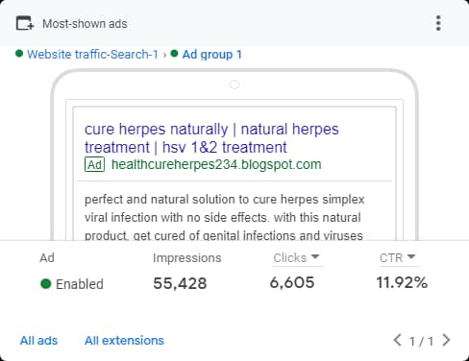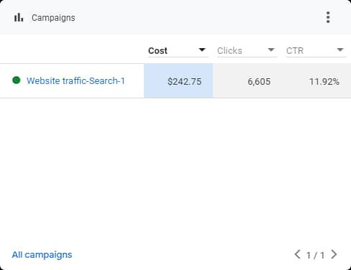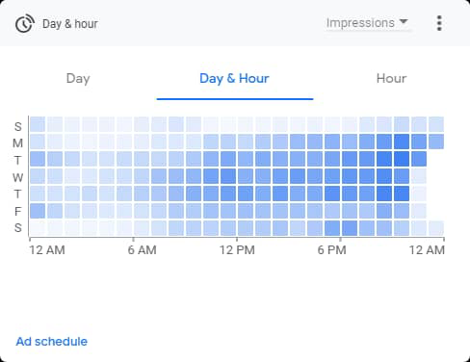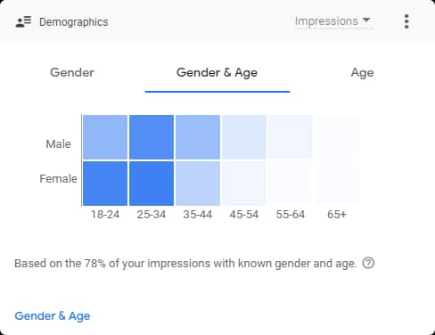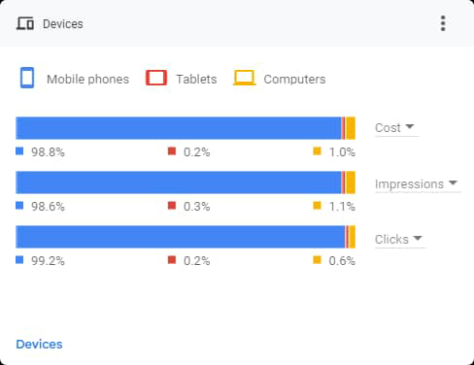
THIRD AD CONT’D
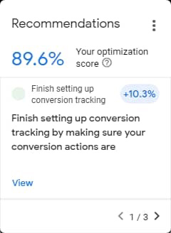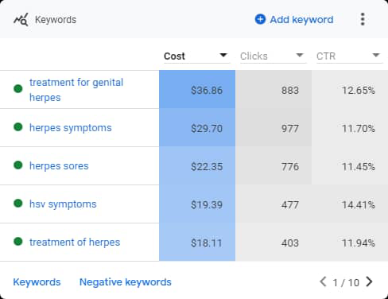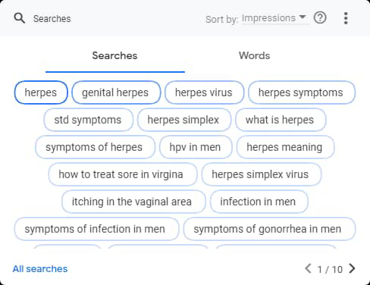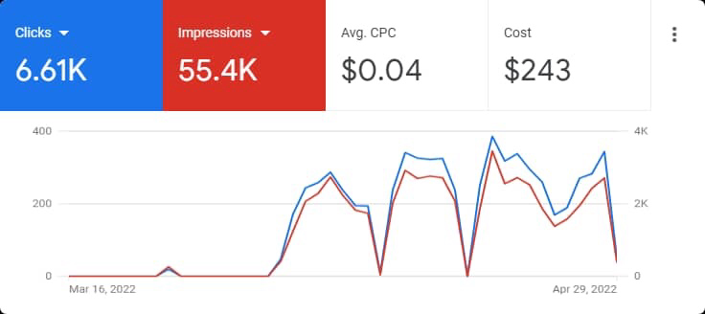
Additional volunteering services
CHURCH ORGANIZATION
REGIONAL TEENAGERS’ VICE PRESIDENT
April 2022 – Till date
RCCG, Region 26.
Ikorodu, Lagos State

PROVINCIAL TEENS VICE- PRESIDENT
CHURCH ORGANIZATION
March 2019 – Date
RCCG, Province 41
Ikorodu, Lagos state.
Accomplishments
- Led a team of over 300 people in each position and organized over 15 programs and events.

References are available on request.

