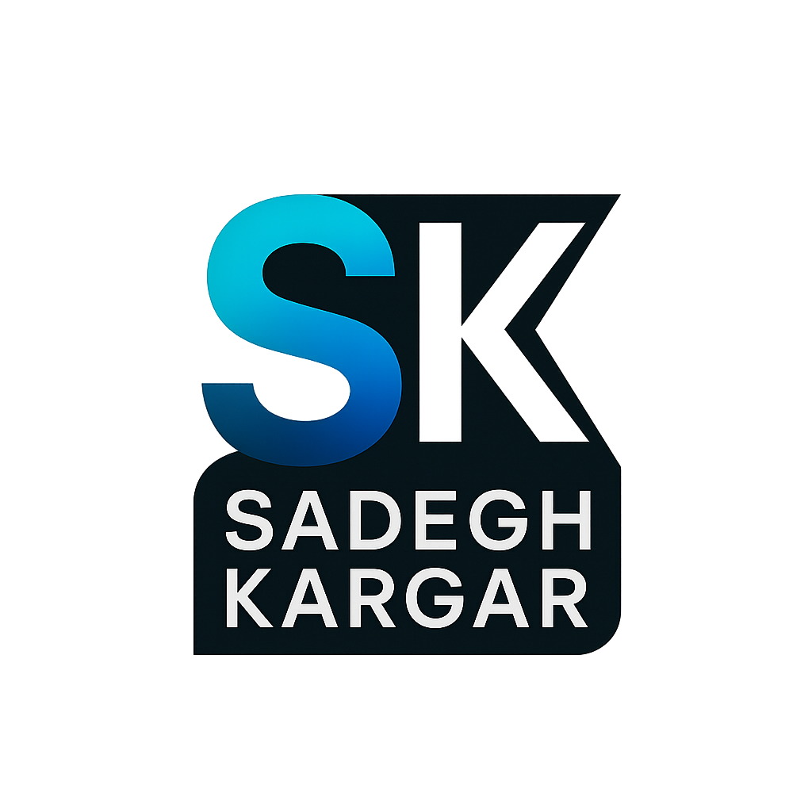**Sadegh Kargar**

**😐Professional Video Editing Portfolio**

**1. Video Editing**

**Project:** Short Social Media Promo

**Service:** Video Editing (trimming, color correction, transitions, text overlays)

**Description:** Edited a 60-second promotional video for Instagram, including custom transitions and animated captions for higher engagement.

**2. Voice Over & Recording**

**Project:** Commercial Voice Over

**Service:** Professional Voice Recording (English, Neutral Accent)

**Description:** Recorded a clear, engaging voice-over for a 30-second product ad, including audio cleaning and mastering.

**3. Subtitle & Translation**

**Project:** English-Persian Subtitling

**Service:** Creating Bilingual Subtitles

**Description:** Added English and Persian subtitles to a tech tutorial video, ensuring perfect timing and translation accuracy.

**4. Audio Noise Removal**

**Project:** Podcast Audio Cleanup

**Service:** Noise Reduction & Enhancing

**Description:** Removed background noise and enhanced clarity for a 20-minute podcast episode.

**5. Simple Motion Graphics**

**Project:** Logo Animation Intro

**Service:** Simple Motion Graphic (Animated Logo)

**Description:** Created a 5-second animated logo intro for a YouTube channel. Used modern transitions and sound FX.