CV

Edris Kohdamani

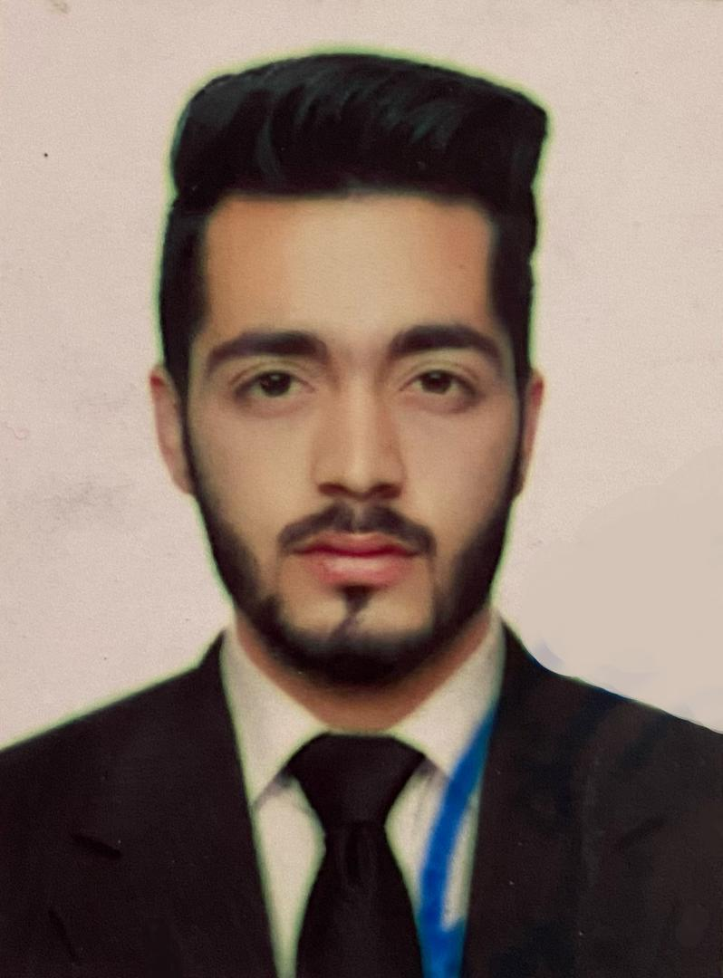

# PROFILE

Full name : Edris Kohdamani

Address: District 17th Kotal Khair khana

Gender: Male

Marital Status: Married

Date Of Birth: 28 Aug 2000

Place of birth: Kabul Afghanistan

Nationality : Afghan

# CONTACT

PHONE:

+93 78 648 7582

EMAIL:

[Edrisskhan001@gmail.com](mailto:Edrisskhan001@gmail.com)

# REFERENCES:

Allah Mohammad Kohdamani

(0093- 78 479 5855)

# LANGUAGE SKILLS:

|  |  |  |  |
| --- | --- | --- | --- |
| Language | Reading | Writing | Speaking |
| English | Good | Good | Good |
| Dari | Fluent | Fluent | Fluent |
| Pashto | Good | Good | Good |

Edris Kohdamani

# EDUCATION

## Saidal Nasiri High School

Graduated from Saidal Nasiri high school

## Azraksh Academic Center

Successfully I Completed 10 month English in this English Academic.

## Pamir institute

Has Certificate of CIT program from Pamir institute.

* **Afghanistan Seminars Center**

Has a certificate of administration and management

* **Ama e shamal institute of spoken langauge**

Has a Grammar certificate from ama e shamal institute

# WORK EXPERIENCE

## Technical Education and Skill Organizations Test

Admin Assistant from 01/01/2015 up to 12/30/2015

**Technical Education and Skill Organizations Test**

HR Assistant from 01/01/2016 up to 12/30/2017

# COMPUTER SKILLS

# Windows 10

## Microsoft Office 2019

## Word-Excel-PowerPoint

## Other Computer Skill

➢ Typing (Dari, Pashto, English)

➢ Internet

➢ Software installation