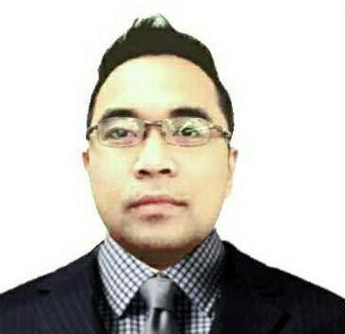

**Michael Iran Licaros**

Blk 5 Lot 30 Masikap St. Fiesta Community

Mabalacat Pampanga

licaros_michael@yahoo.com

Cell No. 0939-004-0351

**Objectives:**

To belong reputable firm requires competent efficient employees; willing to serve with estimated knowledge and skills contributing to the company’s growth and career innovation personally and professionally.

**Personal Information:**

**Age:** 39

**Birth Date:** April 09, 1984

**Status:** Married

**Sex:** Male

**Height:** 5’5

**Nationality:** Filipino

**Religion:** Catholic

**Mother’s Name:** Virgilia Licaros

**Father’s Name:** Melchor Licaros

**Educational Background:**

**Tertiary:** **AMA Computer College 4 Year**

B.S. IT (Undergrad) 2007 - 2010

**Mother of Perpetual Help Institute** Nursing Aid (Graduate) 2004 - 2006

**Secondary:** **Holy Angel University**

Angeles City 1997-2001

**Primary:** **Sto. Rosario Elementary**

School Miranda Angeles City 1991-1997

**Job Experience:**

**Customer Service Representative**

Teletech Pampanga

San Fernando Pampanga

October 8, 2020 – December 23, 2021

**Duties & Responsibilities:**

* Supports customers by providing helpful information, answering questions, responding to complaints managing, and distributing information within an office.
* Resolve Customer complaints via phone, email, or social media.
* Handle and resolve customer complaints.

**Sales Development Representative**

E.A. International Consulting

United States (Work from home)

May 18, 2020 – Sept. 04, 2020

**Duties & Responsibilities**

* Identify the potential needs of the customer, qualify their interest and viability, and create a relationship that will help drive the sale.
* Cold call into prospects generated by a variety of outside sources.
* Profile strategic accounts identifying key individuals, researching and obtaining business requirements, and presenting solutions to start the sales cycle.

**Data Inspector**

ZedWebDev IT Services

Angeles City Pampanga

July 2018 – May 15, 2020

**Duties & Responsibilities**

* Monitors the quality of material documents, records, and information for entry into a database.
* Managing and distributing information within an office.
* Reviewed work orders and accurately input data into the company database.