**Gifted Storyteller Vincent Bozzino Trains the Curious Minds with Bulky, Critical Thinking Workout *“Philosophy Trips. A Naive’s Guide”***

*A witty - and unexpectedly practical - critical thinking crash course for the curious minds to think outside the box, master uncertainty and thrive in disturbing times with unclichéd knowledge.*

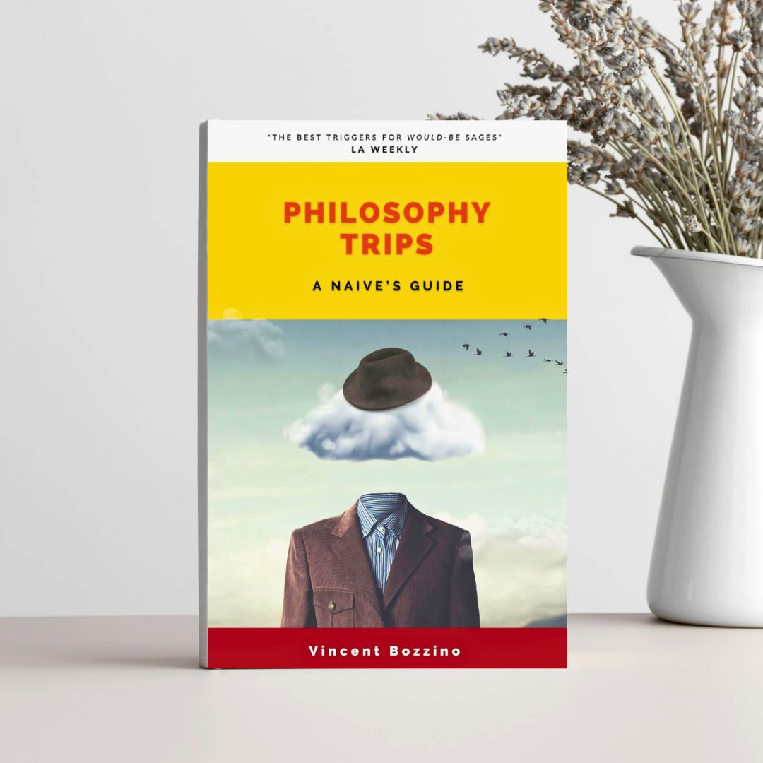

The most comprehensive, light introduction to philosophy in the last 30 years. **© Libertine Press**

In an era where intellectual stimulation is a rare gem, new author Vincent Bozzino emerges as a beacon of light, captivating the minds of the curious with his first non-fiction effort [“Philosophy Trips. A Naive’s Guide”](https://www.waterstones.com/book/philosophy-trips/vincent-bozzino/9781739237738), published by Libertine Press.

The book title alone makes you want to grab your coffee and read on.

Bozzino's *excursus* is nothing short of extraordinary, weaving intricate narratives, plugging all-age curious minds into a breathtaking, critical thinking workout, a brain pump like never before. A weapon of mass instruction, aptly titled *“Philosophy Trips”* takes us on a 12-stop journey of self-discovery and intellectual exploration, essentially probing the history of human beliefs with a giant philosophical magnifier.

The 27-year-old, London-based philosopher - who is also a classical composer, songwriter and rising businessman - schools the *wanna-be* wise to get out of our own way - for truth's sake - with a crash course on big philosophical ideas.

What sets Bozzino’s intro to rational analysis apart is not just its range, but his ability to bridge the gap between high and low culture effortlessly, something academic philosophers regularly fail to achieve with their college compendiums.

On the contrary, his elastic voice resonates with people from all walks of life, arguing across a rich and transatlantic conspectus on a notoriously difficult subject.

Through an oft metropolitan standpoint, in fact, Bozzino audits highly opinionated topics to scratch beneath the surface, dismantling preconceived notions by unveiling hidden angles to the story, we can immediately relate to.



Being a musician, Bozzino's prose has an involuntary artistic touch, infused with a fascinating melodic rhythm, as if he was making love to words.

His real-life, dealmaking skills as a closer add practical allure to the arguments, thus returning a multifaceted, down-to-earth storytelling that knows how to speak to the heart and stimulate to push the envelope.

In a world hungry for *non-partisan*, meaningful debates, *“Philosophy Trips. A Naive’s Guide”* stands out as an underground Cicero, a go-between accuracy and the opportunistic propaganda for those who are slightly sick of abiding by the socially correct banner, at the cost of reasoning, rather prefer the rationally correct and freedom, at the cost of being disliked.

***“Reasoning is not Hate”***

With deliberately controversial kicks like *"Free will, therefore we can kill"* or *"Is it objectively wrong to torture innocent babies, just for fun?”*, Bozzino’s gladiatorial, introductory philosophy book is a real shot in the arm, at intervals a bit recherché for the average readership but definitely a spiritual turn-on, scarce commodity in the dusty popular philosophy market.

He reveals a rather different world than the one we know, upholding how philosophy is «that shadow that all things reveals when the sun of knowledge falls on them» (F. Nietzsche, *Human Too Human*): this is the shadow that Bozzino tries to show.

Having philosophy as your only muse makes this book a very useful guide for the present, to get an idea of ​​your time, learning it through your thoughts and not in front of the television.

This is why I believe that the majority of the readers of *“Philosophy Trips. A Naive’s Guide”*, and not just myself, will choose Bozzino’s out and back cerebral rollercoaster as a neophyte and - somewhat still - biased.

It’s a summer journey of intellectual discovery, the long-standing plot is stretched and boundaries are pushed. Come winter, you won’t ever be the same.

*Philosophy Trips. A Naive’s Guide* by Vincent Bozzino, published by Libertine Press (£19.99) is available in all global stores.