On May 11, on the first day of trading, the DFINITY project management token entered the top 7 assets by market capitalization with an indicator of $ 51.6 billion.

After the successful launch on May 7 of the genesis block of the Mercury network, the native Internet Computer (ICP) token was listed on the exchanges Coinbase Pro, Binance, FTX, Huobi and OKEx.

The ICP price at the moment peaked at around $ 730 (the total market value exceeded $ 100 billion). Subsequently, quotes stabilized around $ 400.

From the genesis block, the ICP unlocking process began for the participants of the token sale in February 2017 and the airdrop in the summer of 2018. Within 12 months, the latter will receive the remaining tokens in equal parts. At the moment, a third of those envisaged by the ICP have been circulated.

In the future, a mechanism for distributing tokens between representatives of non-profit organizations Internet Computer Association and DFINITY Foundation, team members, consultants, early participants will be determined.

The NNS ICP service token performs the following functions:

facilitating network management using neurons participating in voting on proposals;
production of cycles for computations;
reward for voting participants and node providers.
ICP bidding was preceded by five years of development and four project phases (Copper, Bronze, Tungsten and Sodium), as well as alpha and beta versions of the mainnet as part of the Mercury phase.

DFINITY is positioned as a decentralized "internet computer". The project team strives to create the first blockchain operating at internet speed with unlimited bandwidth, being decentralized, secure and scalable.

It will be possible to create websites, corporate IT systems, industry-wide protocols, scalable open web services, DeFi and NFT on the Internet computer network.
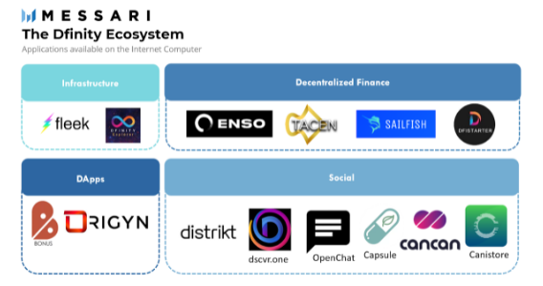
DFINITY is also marketed as an alternative to Amazon Web Services. The developers expect to break the monopoly of the IT giants' centralized platforms by creating decentralized alternatives to Uber, eBay, Facebook and other well-known platforms.

Currently, the DFINITY ecosystem brings together dapps, decentralized social media, DeFi, and infrastructure applications.

In February 2018, Polychain Capital and Andreessen Horowitz invested $ 61 million in DFINITY.In the same year, the project conducted a closed token sale to accredited investors, raising another $ 102 million.

As a reminder, in June 2020, DFINITY opened its protocol to third-party developers.

