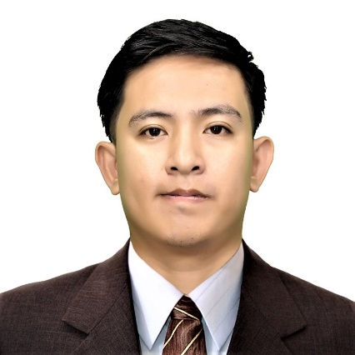
MANGUNE, MILENCE GOPEZ

CURRENT ADDRESS: Sitio #10 Sto. Niño Triangulo, City of San Fernando, Pampanga
CONTACT NUMBER: 0918-4828-986
E-MAIL ADDRESS: milencemangune00@gmail.com

OBJECTIVE:

To render service to the company with a sense of responsibilities.
To gain more knowledge and experience and to improve my skills.
To earn money so that I can save to provide remaining two semesters for my Bachelor’s Degree for my future.

PERSONAL INFORMATION

Age: 28 yrs. old
Birth Date: October 29, 1990
Gender: Male
Height: 168cm.
Weight: 72 Kg.
Civil Status: Single
Religion: Roman Catholic
Citizenship: Filipino
Father: Orlando B. Mangune Sr.
Mother: Rowena G. Mangune

EDUCATIONAL ATTAINMENT

TERTIARY: Don Honorio Ventura Technological State University (Main Campus)
Bacolor, Pampanga
Bachelor of Science in Architecture (4th year Standing Under Graduate) 2018

SECONDARY: Pampanga High School
High School Blvd. San Fernando, Pampanga (2003 - 2007)

PRIMARY: Sto. Niño Elementary School
Mercury Street San Fernando Subdivision, City of San Fernando, Pampanga
(1997 - 2003)

WORKING EXPERIENCE

PROVINCIAL ASSESSOR’S OFFICE
Capitol Blvd. Compound Brngy. Sto. Niño, City of San Fernando, Pampanga
Administrative Aide I
(August 1, 2019 to December 30, 2019)

HANDYMAN DO IT CENTER
Robinsons Starmills, City of San Fernando Pampanga
Matimco: (Wood Specialist)
(February 2011 to August 2011)

BLUE MAGIC
SM City Pampanga
Sales Staff (seasonal)
(November 22,2010 to January 4, 2011)

THE FRENCH BAKER
SM City Pampanga
Position: (Baker/Mixer)
(June 24, 2010 to November 14, 2010)

UNIVERSAL ROBINA CORPORATION (URC GD9)
Del Rosario, City of San Fernando Pampanga
Position: Machine Operator
(July 22, 2008 to December 15, 2008)

JOLLIBEE FOODS CORPORATION
Dolores Junction, City of San Fernando Pampanga
Position: Service Crew
(October 4, 2009 to March 14, 2010)

HIGHLIGHTS OF QUALIFICATIONS

- Computer Literate (Auto Cad, Sketch Up, Microsoft Word, Excel, etc…)
- Able to work independently and cooperative to others and able to direct and make decisions.
- Hardworking, flexible, patient, confident and committed in working and with other people.

CHARACTER REFERENCES

Engr. Manuel N. Mendoza Jr. Pulungmasle, Guagua, Pampanga
Provincial Assistant Assessor Pampanga
09321875889

Ret. Gen. Narvin S. Mangune St. Anthony Subdivision, (CSFP)
Deputy Regional Director Pampanga Provincial Office
(045) 963 47 28

Janette Formanez-Amores Kalayaan Village, (CSFP)
SEPS-SMME (Senior Education Program Specialist in School Management, Monitoring and Evaluation) DepEd (Region 3)
09452680603

I HEREBY CERTIFY that the above information is true and correct to the best of my knowledge and beliefs.

Milence Gopez Mangune
Applicant Signature

