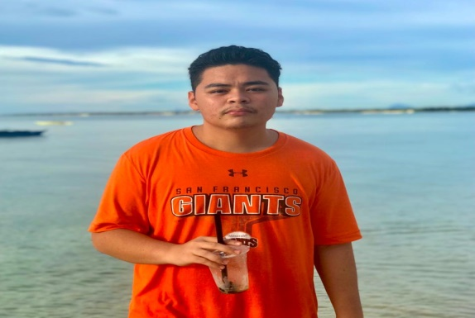

**KING BERNARD S. LUCHE**

Address: Bakhawan, Daanbantayan Cebu

Contact No: 09151659306

Email: [Kingluche12@gmail.com](mailto:Kingluche12@gmail.com)

**CORE QUALIFICATIONS**

* Time management
* Reliable
* Fast learner
* Patient
* Adaptable

**GAMING EXPERIENCE**

MLBB started playing in year 2018

* Reached Mythical Glory with 1100+ points

DOTA started playing in year 2014

* Reached Legend with 4000+mmr

**GAMING DEVICE**

* Android phone
* Laptop

**WHY AM I APPLYING FOR A SCHOLARSHIP?**

I noticed that i have a lot of free time wasted just by strolling in the internet and playing games without earning anything and i noticed that my family today is having financial issues thats why im trying to find some extra jobs thats fit for me like gaming because ever since i was young im really into esports.

**WHY SHOULD YOU HIRE ME?**

My eagerness to win and my willingness learn on any game is the reason on why you should hire me plus i am passionate of what im doing and i would take this job seriously