PERSONAL INFORMATION. PROFILE.

- Nacionality: venezuelan.
- Born: 3nd August 1994
- Age: 27 years.
- Civil State: Single.

EDUCATION.

Mechanical Engineering.
Universidad Nacional Politécnica de la Fuerza Armada Nacional (UNEFA) Caracas-Venezuela 2011 – 2016

High School.
“Instituto Victegui” Los Teques-Miranda 2006 - 2011

EXPERIENCE.

Colegio Bilingüe de Panamá C.B.P.

(15/02/2020- 15/12/2022)

Charge: Teacher.

Math Teacher, grades: 10th y 11th

Achievements:

Designed methodologies for the teaching of mathematics in the virtual environment.

- Collaborated in the certification of the ISO 9001 Standardization, through teaching evaluation by the accreditation staff

Saint George, International School of Panama. (26/09/2017- 21/12/2019)

Charge: Teacher / Science Coordinator.

- Teached the subjects of elementary mathematics, geometry, trigonometry, algebra and physics in all level- high school.

- Coordinated the scientific events for the entire school, highlighting the participation in the activity: Young Scientists of the year 2019 in Panama City.

- Mentor of the project entitled "Use of yam residues and titanium dioxide nanoparticles (TIO2) for the synthesis of bio-polymeric films" Young Scientists Program 2019-Senacyt.
- Mentor in the National Olympic of Physics 2019.

- Mentor in the National Olympic of Mathematics 2018-2019.

Ingeniería de Sistemas Térmicos IST C.A. Venezuela

(22/03/2017 – 03/07/2017)

Charge: Operation Assistant.

Designed and executed maintenance plans of A / C belonging to the Venezuelan Institute of Social Security (IVSS) regions of Oriente and Vargas

Mechanical Engineer, capable in the use of many resources and technologies mainly mechanical and administrative, innovation in own technologies and adaptability in development of new process, products and services. Highlighting a self-learning in different levels of knowledge that have allowed a right decition making in personal, academic and professional enviroment.
Workplace Competencies.
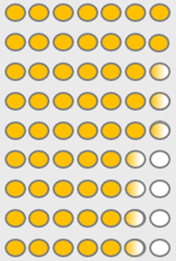
DATA ANALYSIS EFFECTIVE COMMUNICATION
INTERPERSONAL SKILLS
RESULTS-ORIENTED
CUSTOMERORIENTED
LEADERSHIP
TEAMWORK
PROCESS DESING
INNOVATION

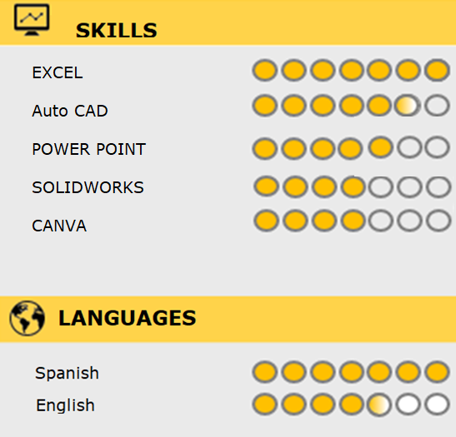
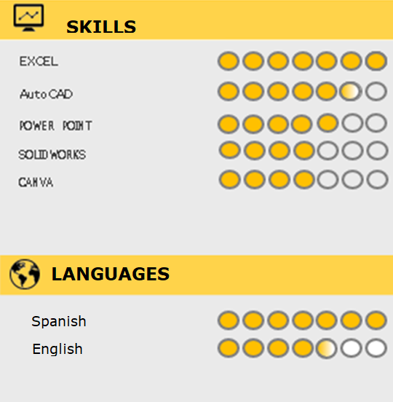
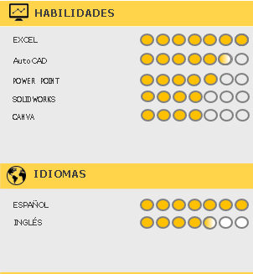

PREFERENCES
EXPERIENCE.
EXPERIENCIA LABORAL

Instituto de Tecnología Venezolana para el Petróleo (INTEVEP),

Venezuela (01/02/2016-15/06/2016)

• Developed the project of "hydraulic evaluation of the Fire fighting

water system" of PDVSA-INTEVEP S.A

• Updated the existing plans of the main fire network of INTEVEP.

Through by hydraulic calculation, determinated the pipe’s sections of

the fire network they needed be replaced.

PERSONAL REFERENCES.

Mgt. Amalfi García.
SOCIAL MEDIA
www.linkedin.com/in/gabriel-jose-figueroa-pacheco-50942994
School principal Colegio International Saint George
+507-6216-7919
www.linkedin.com/in/gabriel-jose-figueroa-pacheco-50942994 c

Gabrielfigueroa 1994
E-mail: agarcia@stgeorge.edu.pa

Lic. Carmen López.

Vice principal at Colegio Bilingüe de Panamá.

+507-6273-6379
E-mail: carmenjulialopezch@gmail.com

Ing. Keysi Sayago

Project Coordinator at CMS Group LTD-

Tel: +1(437) 980-5882
Email: Keysi484@gmail.com
2

