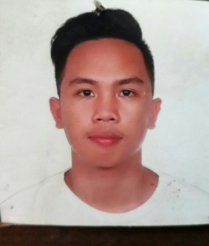**AVES, MARCIAL C.**

9 F. Rallos St. Pasil, Cebu City

Cell No: 09617303043

**OBJECTIVE:**

Looking for a position where I can enhance my talents and skills with a friendly and competitive surrounding.

**PERSONAL DATA:**

* Birth Date: August 6, 1999
* Birth Place: Cebu City
* Age: 21
* Height: 5’8
* Gender: Male
* Civil Status: Single
* Nationality: Filipino
* Religion: Roman Catholic
* Languages: English, Cebuano, Filipino

**EDUCATIONAL BACKGROUND:**

* SECONDARY: Cebu City Don Carlos A. Gothong Memorial National High School

SY: 2015-2016

* Don Bosco PasilTechnology Center - Cebu  
   SY: 2018-2019

**SKILLS AND ABILITIES:**

* Self motivated to learn new technologies and works hard.
* Willing to shoulder challenges and responsibilities.
* Flexible can work under pressure, hardworking and willing to work overtime.

**WORK EXPERIENCE:**

* **OJT**– LATHE MACHINE OPERATOR

Pusok Mepz1 Lapu-Lapu

:2019-2020

**CHARACTER REFRENCES:**

* **Armando Barulo – Maintenance**

09957551496