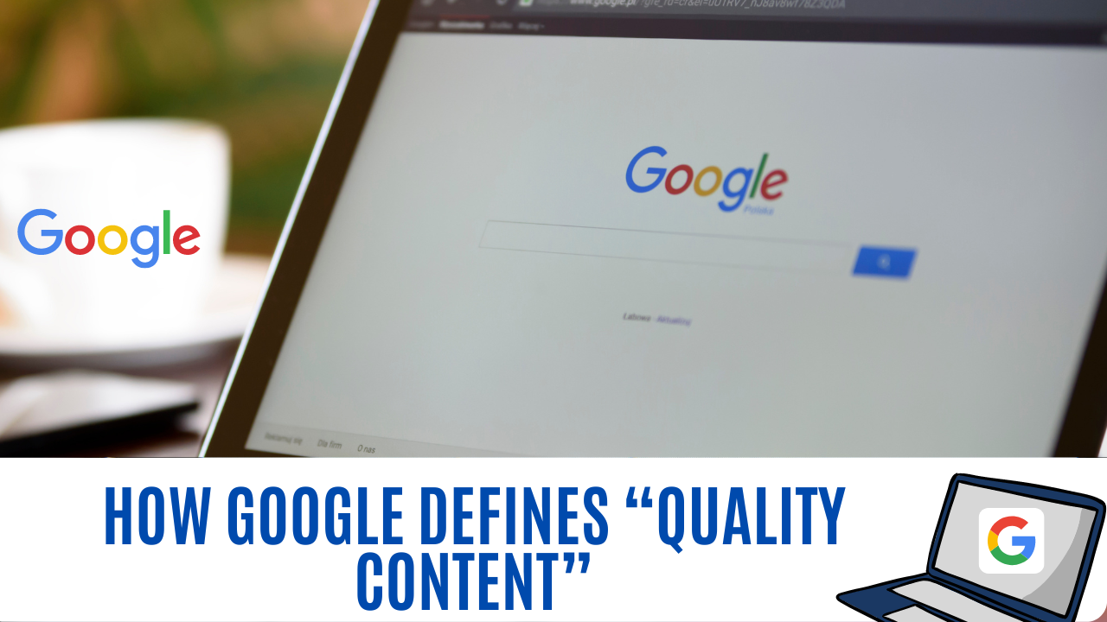

How Google Defines “Quality Content”
First, let’s talk about some of the basics. Content refers to any copy or images on your website – from your blog posts, to your ‘About Us’ page, to your logo. Content marketing refers to an inbound strategy wherein companies create blogs, eBooks, and emails meant to inform or entertain a targeted audience in an effort to acquire and retain customers. This can happen via organic search or paid advertising that points to the content. When Google says you need to have “quality content,” it means:
- Each page on your site must serve a clear purpose. Is it to inform? Collect information? Provide directions or company details? It should be apparent at first glance, or your bounce rate will soar.
- The content must be original, well-written, and researched. We call this a “comprehensive” piece of content.
Google doesn’t want to tell us everything about how to rank highly, but it does want us to produce valuable content. As such, the search behemoth provides detailed guidelines on what we should and shouldn’t do, with an emphasis on the “shouldn’t.”
- Make pages primarily for users, not search engines.
- Don’t deceive your users.
- Avoid tricks intended to improve search engine rankings. A good rule of thumb is whether you’d feel comfortable explaining what you’ve done to a website that competes with you, or to a Google employee. Another useful test is to ask, “Does this help my users? Would I do this if search engines didn’t exist?”
- Think about what makes your website unique, valuable, or engaging. Make your website stand out from others in your field.
Many of Google’s rules and guidelines are meant to prevent manipulative or deceptive behavior, so we’ll get some of the more obvious ones out of the way right now.
Per Google, avoid:
- Automatically generated content
- Participating in link schemes
- Cloaking
- Sneaky redirects
- Hidden text or links
- Doorway pages
- Scraped content
- Participating in affiliate programs without adding sufficient value
- Creating pages with malicious behavior, such as phishing or installing viruses, etc.
- Abusing rich snippets markup
- Sending automated queries to Google
At best, people using these tactics are doing so to pad their traffic metrics, usually to either drive ad revenue or increase the value of a monetized website. At worst, they’re trying to steal information. The point is, if you’re using these tactics, you already know what they are, so we won’t dig into them. We’ll leave it at this: These tactics will not bring you customers, but they may get your site shut down or penalized.
Now that we’ve weeded out anyone looking for the quick-and-dirty route, let’s talk about some of the more nuanced guidelines Google provides.
Avoid creating pages with little or no original content:
What this means: If there’s a page on your site that doesn’t provide any value to users, it probably doesn’t need to be there. Do an audit of your site to make sure each page has relevant, quality content and a defined purpose.
Don’t Load pages with irrelevant keywords
What this means: In the early days of content marketing, a somewhat common practice was to write filler content stuffed with keywords to trick the algorithm into ranking the site highly. It was a bad idea then, and it’s an even worse idea now, as Google can now detect and penalize sites that use this tactic. This is also known as “keyword stuffing.”
Neither human nor machine will respond positively to sites with the issues mentioned above, so if you’re guilty of publishing thin or keyword-stuffed content, you should prioritize having it re-written. On that note, let’s talk about the great content Google does want to see.
There are five basic characteristics of what Google considers quality content:
- Useful and informative. If you’re only posting to boost rankings, you’re posting for the wrong reason. You need to answer your user’s questions or delight them with your content.
- Provide more value than what already exists. The internet is a deep pool with a lot of content. One way to rise to the top is to look at what others in your industry are doing and do it better.
- Credible and accurate. Do your fact-checking and cite sources that have high trust signals, and you’re golden. It also doesn’t hurt to display your site author’s biography and case studies or testimonials to show you’re legit.
- High-quality. There it is again, that nebulous term. In this case, we’re talking about content that is free of typos and errors and provides a user-first experience with an easily digestible format. (Notice this easy-to-read bulleted list? Hint hint)
- Engaging and focused. Your site should look lively but avoid clutter and distractions. Post quality images and graphics that match your brand. Then engage readers using widgets that inform visitors (and collect leads). Don’t overdo it on the lead collectors, though. It detracts from the user experience.
This isn’t rocket science, but it does take some work. If the thought of writing and doing research gives you hives, consider outsourcing your content writing to a freelancer or an agency. You’ll save yourself time by delegating the job, and you’ll likely end up with better quality when you hire an expert versus going it alone. Small businesses may enjoy the flexibility and lower costs of a freelance content writer, while larger companies may find it worthwhile to hire a full-scale agency for content production.
Now that you know how Google defines the good, the bad, and the ugly of content, let’s get into the nitty-gritty details.
What Quality Signals Do Search Engines Look For?
As sophisticated as the Google algorithm has become, it still needs human intelligence to help it assess the quality of content. It’s no longer a secret that the search giant has a worldwide army of thousands of search quality evaluators who give ratings to individual pages on the web. In fact, you can view the very extensive search quality guidelines they follow. It’s worth a read, but be sure to carve out some time before digging in.
Here are the most important factors of page quality rating, per Google’s guidelines:
- Quality and quantity of the main content (i.e. the part of the page meant to achieve a goal)
- Visibility of website author information
- Website reputation
- Level of expertise, authoritativeness, and trustworthiness of the content
The lowest scores go to sites that use malicious or black-hat practices already discussed. We know you’re an honest marketer, so we won’t be redundant. But if you have any content on your site that may be old or was posted hastily, it’s a good idea to do a full audit to ensure that your site is free of content that is plagiarized, inaccurate, error-ridden, distracting, repetitive, or common knowledge with little or no new value. Raters will score sites with this type of content poorly. If a page has no clear purpose, it will receive the lowest possible rating, so be very thoughtful about your goal for each page and create content targeted to achieve it.
Conclusion:
Content quality is not just about the text itself and its various attributes. Instead, Google looks at your site as a whole to qualify whether the content you share is indeed high-quality. And because quality content is a critical component of any high-converting digital marketing strategy, paying attention to your website’s design and UX improves your ability to perform on the SERPs significantly.

