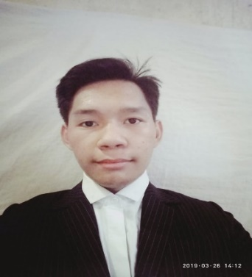**Rafhael G. Segunto**

219 Magsaysay St. Tondo Manila

Contact No: 09166971578

seguntorafhael@yahoo.com

**Objective**

To obtain a position that will enable me to use my strong organizational skills and ability to work well with people.

**Personal Information**

Age: 19

Birthdates: Nov 2, 2001

Birthplace: Manila

Gender: Male

Height: 5’5

Weight: 49 kilos

Civil Status: Single

Language Spoken: Filipino and English

Citizenship: Filipino

Religion: Roman Catholic

Address: 219 magsaysay St. Tondo Manila

Mothers Name: Rodelia Segunto

Occupation: HouseWife

Fathers Name: Pedro Segunto

Occupation: Vendor

**Educational Background**

Primary  Amado V. Hernandez Elementary School 2010-2011   
 Sto. Niño Street, Barrio Magsaysay, Tondo

Secondary Florentino Torress High School 2014-2018  
 Juan Luna St. Tondo , Manila, Metro Manila

Senior High school Philippine College of Criminology 2018-2020

Sales St, Tondo Manila, Metro Manila

College The Eulogio "Amang" Rodriguez Institute 2020-2021

of Science and Technology

**______________________________________________________________________**

**Skills and Learnings**

Socialize well with other people

Ability to work under pressure

Good communication skills

Willing to learn new things

I hereby certify that the above information are true and correct to the best of my knowledge and belief.

Rafhael G. Segunto

(Applicant)