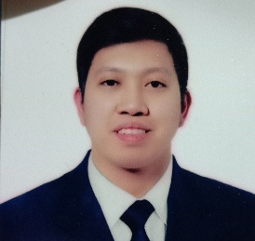KENNETH Q. CANDELARIA

#61 Sierra madre st, brgy highway hills,

mandaluyong city

09272598285

[Kenquindoza@gmail.com](mailto:Kenquindoza@gmail.com)

# Objective:

To be part in a company that will allow me to utilize my skills and education while expanding my potentials and to land a wonderful career that would enable me to grow personality and can train me professionally.

# Education Background:

## Tertiary:

Bachelor of Science and Information Technology

Camarines Norte State College

Daet,Camarines Norte 2013-2014 (Undergrad)

# Work Experience:

* SM Appliance Center (Warehouse) Stock Clerk

Ugong, Pasig City

### Responsible for receiving merchandise, unloading and unpacking it, marking it with codes to be identified, stocking shelves, and helping customers place orders. Works in stores, warehouses, stockrooms and other storage facilities. May involve heavy lifting.

* Holiday Inn and Suites Makati Kitchen Steward

Ayala, Makati City

Primarily responsible for operating and maintain cleaning equipment and tools. Also responsible for washing dishes, china ware, flatware, cutlery, crockery, kitchen vessels, sweeping and mopping floors, cleaning and detailing equipment’s.

* Holiday Inn and Suites Makati Kitchen Chef(Present)

Ayala, Makati City

**Special Skills/ Qualities:**

* Can communicate in Tagalog and English Language.
* Knowledge in some Microsoft Office Tools.
* Fast learner, Hardworking, Organized.

**Personal Data:**

**Birth Date: November 28,1996**

**Birth Place: Pasig City**

**Gender: Male**

**Height: 5’8 ft**

**Weight: 175 lbs.**

# Awards and Acknowledgements

* **National Certificate II in Cookery**

**September 8, 2017 to September 7, 2022**

* **Basic Occupational and Safety Training**
* **Environmental Health and Sanitation & Regulation**

**This is to certify that above information is true and correct with all my knowledge.**



**KENNETH Q. CANDELARIA**

