Creative Ways To Relax In 2021
Meta Title: Creative Ways To Relax In 2021 | Personal Growth Channel

Meta Description: If you want to learn creative ways to relax in 2021, here are the best creative ways to help you relax and recuperate in this busy world we live in. Discover new things that you can do to unwind and enjoy life more without losing yourself to stress.

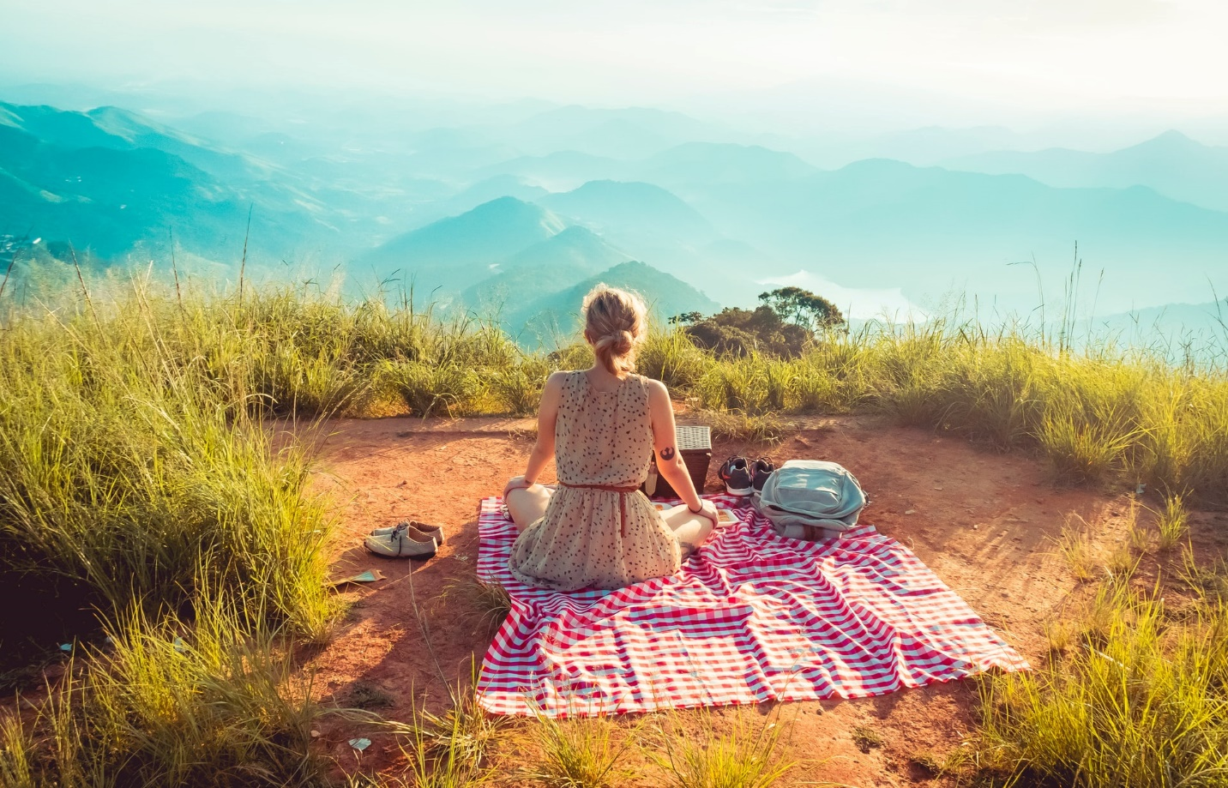
Photo by William Justen de Vasconcellos

Today's fast-paced, ever-busy lifestyle may actually become a threat to your health in the long run. Although the spirit is willing, the body is getting weaker every day.

People know that they need to unwind and relieve their stress, but it's not always easy. It can be challenging when you're constantly on the go or have a demanding schedule with little time for relaxation. This is why more people are now into meditation and other means of relaxation techniques to relieve stress, and stay healthy.

How can you avoid being stressed out and keep your sanity by finding simple yet creative ways to relax in 2021?

What are some ways to relax when Stressed?

1. Try a New Hobby
If you’re looking for more ways to relax in 2021, try something new. Find a new activity you enjoy and pick a time that works for you. Clear your mind of day-to-day stresses and start focusing more on creative activities that relax your mind and body. Spending at least an hour everyday doing something you love is one of the ways of self-care.
It could be activities like photography, indoor biking, creative writing, or meditation; whatever you choose, set aside time for relaxation and adapt it to your own schedule. People with hobbies are less likely to suffer from stress, low moods, and depression. It’s one of the ways to relax that get you out and about can make you feel happier and relaxed.

2. Help Other People
Taking a break from focusing on yourself and your work by reaching out to help someone else in need can be very rewarding. It might feel like you are being selfless, but the rewards of giving without expecting anything in return outweigh all other feelings when it comes down to how refreshed you will feel afterward.
Focusing on helping others helps you remember that there is more than just what's going wrong with you at any given moment. It also resets your perspective, fuels creativity, and is one of the best ways to relax to face whatever challenges may come next.

3. Have a Work-Life Balance
In today’s hectic world, where the pressure to be more productive surpasses everything else, being busy and hyper-active is seen as a sign of success. With so many tasks constantly on the go, it becomes easy to feel overwhelmed by everything that needs your attention.
Stressful days at work can be cut down by avoiding responsibilities and working fewer hours. You may even feel better about your job if you say "no" a little more often because it will allow you to take care of yourself first. This, in turn, lets others know that their needs are not always a priority. It’s also one of the best ways to relax with your partner and loved ones to build onto those lasting relationships.

4. Take a Walk
A walk in the park is a great way to unwind when stressed. It allows you to take more time off and get some much-needed exercise. You might choose to do this during your lunch break or after work hours, both of which provide you with the opportunity to add additional health benefits that are important if you want a healthy heart to maintain normal blood pressure levels.
Walking is a great way to release endorphins that help promote relaxation and improve mood. Even a leisurely stroll around the block can have numerous benefits to relax your mind.
What is the best way to relax? It could be as simple as finding a hobby that helps you de-stress, such as reading or painting. Or it may require more work like helping other people in need. The key is to do something that works for you. Have you tried any of these creative ways to relax? Let us know how they worked out for you in the comments below.

